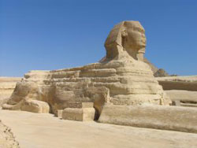
The Great Sphinx, Giza, Egypt
Dynasty 4, c. 2613-2494 b.c.e.
Sandstone, 65’

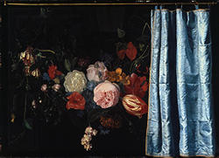
Flower Piece with Curtain, 1658. Oil on Panel. 18.25” x 25.25” Art Institute of Chicago. Adrien van der Spelt and Frans van Mieris
Red and white tulip symbolized wealth and power. Most realistic painting at the time. Iconography and Symbolism

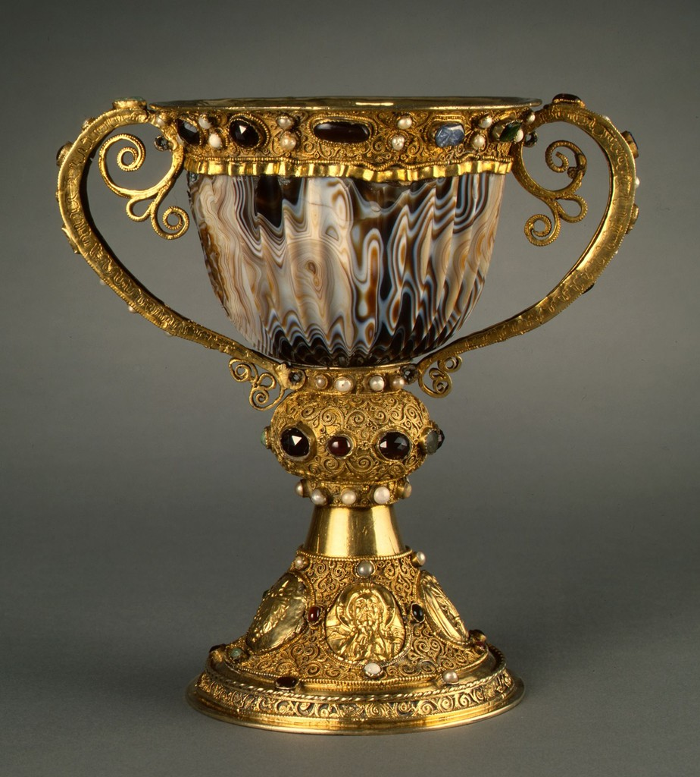
Chalice of Abbot Suger, France. C. 1140 c.e., Silver Gilt, Filigree Pearls, semi precious stones. 7.5” x 4.25”

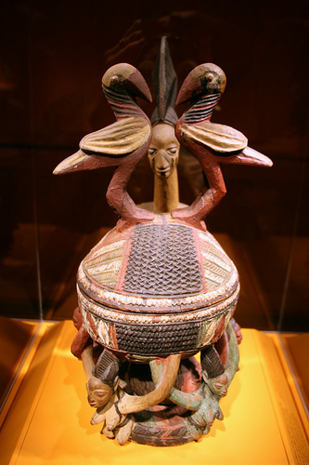
Olowe Offering Jar. Natural Museum of African Art. c. 1925, wood and pigment

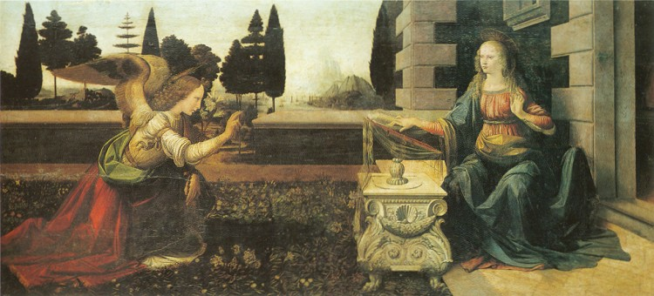
“The Annunciation” Leonardo da Vinci.
Mary – Red and Blue (Humanity and Divinity)
Gabriel- Halos and Wings
Corinthian Columns, Renaissance Robes, and water and mountains under Hazy Sky was da Vinci not Boticelli

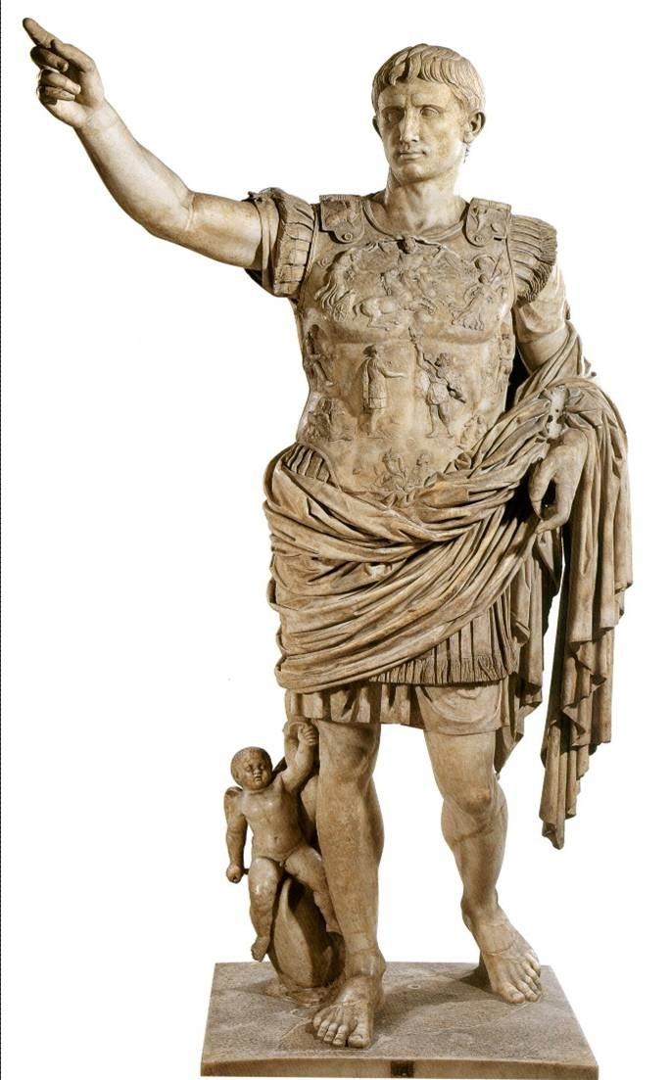
Augustus of Prima, Porta, Rome.
c. 14-37 b.c.e. Marble, 6’8”
Chest plate tells story (symbolism). He got eagle back after Crassus Lost it. Parthians took it.
Controposto Style.
Baby is Cupid for love and he is on a doplphin patron of Venus
Augustus claimed to be descendant of Venus. No shoes represented gods.

Right hand raised orator

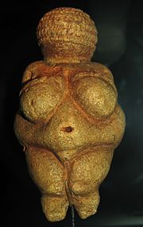
“Woman from Willendorf” Australia, c. 22000-21000 b.c.e. Limestone, 4 ³/₄ “

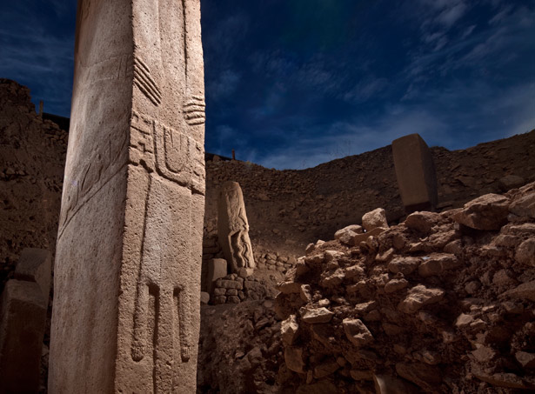
Gobekli Tepe, Turkey Neolithic circle of monoliths on a hill
Oldest known man made religious structure c. 9000 b.c.e.
“1st came the temple then the city.

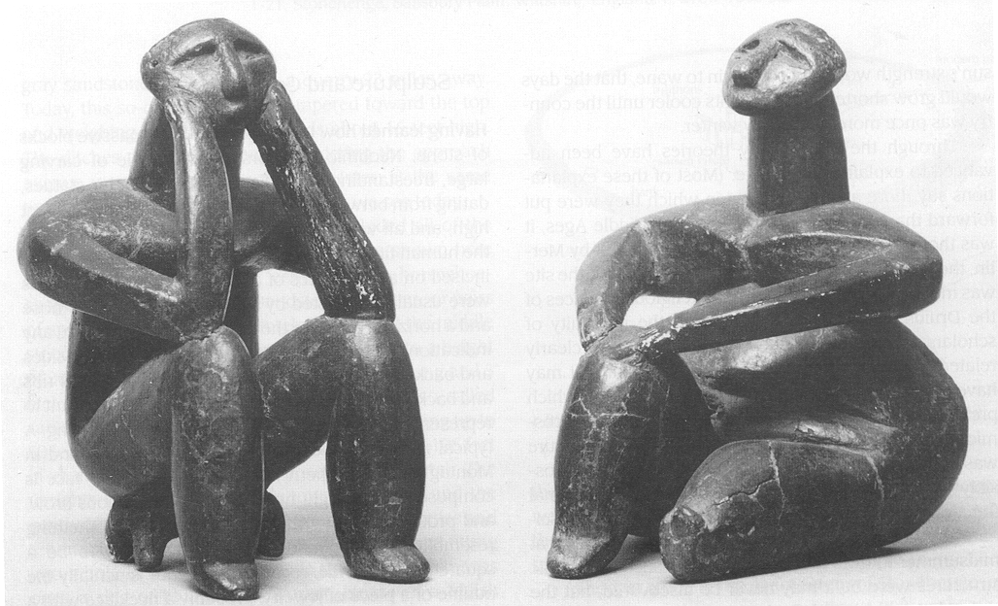
Female and Male Figures, c. 3,500 b.c.e. Romania, 4.5”

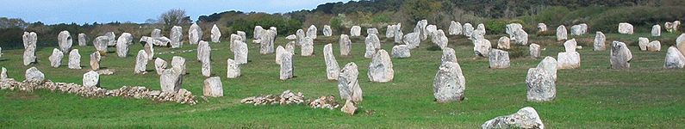
Menhir Alignments at Menec. C. 4,250-3,750 b.c.e. Carnac, FR

Megalithic- huge blocks of stone to mark a site
Post and Lintel- 2 supporting stones and then one upright one

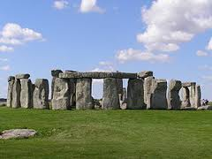
Stonehenge, c. 2,100 b.c.e. Salisburg Plain, England. 97’ diameter
Friar’s Heel- rock thrown by devil that landed on friar for talking back to the devil that is a random rock right next to the road.
Believed to be a calendar.

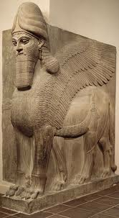
Human-headed Winged Lion (Lamassu). Assyria 883-859 b.c.e. Limestone, 10’3”

Horns show godship Eagle wings show strength

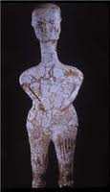
Figure from Ain Ghazal. C. 7,000-6,000 b.c.e. clay, plaster, paint. 36”

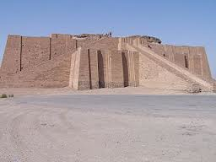
Nanna Ziggurat, Ur, Mesopotamia. C. 2,100-2,050 b.c.e.

Nanna- Moon god in Iraq

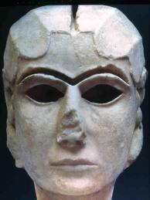
Face of a Woman, Uruk. C. 3,300-3,000 b.c.e. Marble, 8”

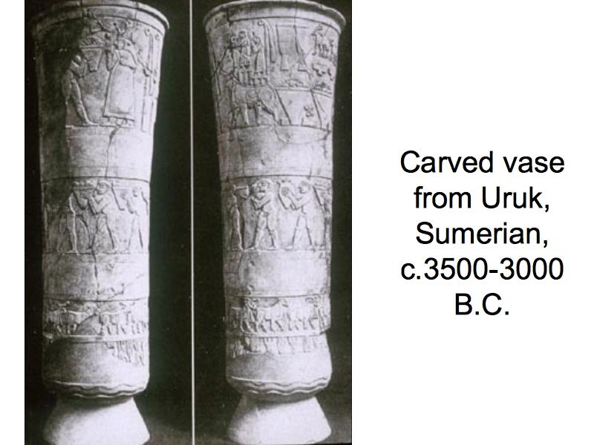
Register- Tells stories
At the top there is a goddess receiving a gift.

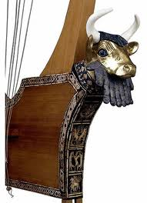
Great Lyre with Bull’s Head, c. 2,550-2,400 b.c.e. Wood, gold, Silver Lapis (Blue rock from Afghanistan), Lazuli, shells

Hybrid- Mix of any two things

Iconography- Bulls head represents strength.

Funeral Celebration

Heiretic Scale
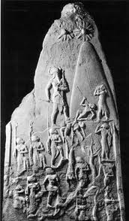
Stele of Naram-sin, c. 2,254-2,218 b.c.e. Limestone, 6’6”
3 suns represent gods
Imperial Authority

-His Soldiers

-soldiers defeated by Naram-sin

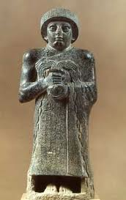
Votive of Gudea, c. 2120 b.c.e. Diorite (very hard stone), 29”

Hands crossed= reverend devotional/ peaceful

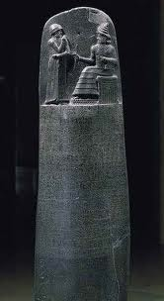
Stele of Hammurabi, c. 1792-1750 b.c.e. Basalt, 7’
<-Shamash (god)
High relief (Sticks out a lot)
Hammurabi’s arms represent reverence towards the gods
Shamash staff represents authority
3 tiers under Shamash represents mountain.
Code underneath Shamash and Hammurabi showing that he got the code from the gods.
Measuring rod and circle rope representing judgement

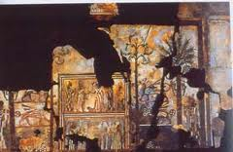
Investiture of Zimri Lim (King of Mari before the goddess Ishtar), c. 1,750 b.c.e. Wall Painting on Mud Plaster. 5’5”

Ishtar goddess of love, fertility and war. She is holding weapons with foot on lion
Water of life shooting out of vase surrounding gods

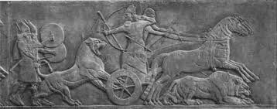
Assurnasirpal II Killing Lions, c. 850 b.c.e. Alabaster. 39” Mesopotamia

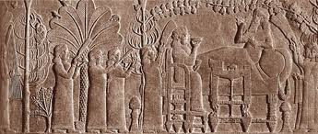
Assurbanipal and His Queen in the Garden. C. 647 b.c.e., Alabaster, 21”

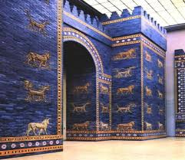
Ishtar Gate and Throne Room. C. 575 b.c.e. Glazed Brick 40’ gate and 100’ towers
Ave. from Euphrates bridge to gate used for celebrations mainly for Marduk
Guarded by 4 crenellated towers decorated with Mushhushshu, horned dragon beasts sacred to Marduk. Blue horned bulls are associated w/ Adad
Nebuchadnezzar built it and made Babylon hub of culture, Economy, and politics

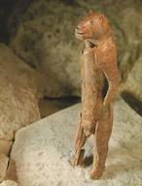
Hybrid Figure with Human Body, Mammoth Ivory (very brittle)

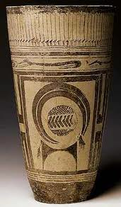
Beaker from Susa, c. 4,000 b.c.e. Ceramic, brown glaze. 11.25”

Ibex
Abstract object
Motif

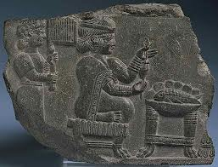
Woman Spinning, c. 8th-7th century b.c.e. Bitumen Compound
Know shes wealthy because of her hair and her servant.

Flounced dress in bottom right corner. Worn by gods

Fish and fruit (possibly) to be sacrificed for gods.

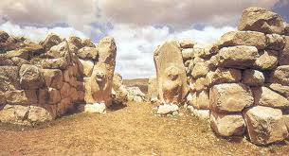
Lion Gate, Hattushash (Turkey) c. 1400 b.c.e. Limestone

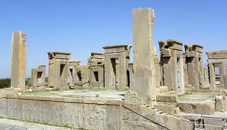
Parsa
Apadana of Darius I and Xerxes c. 518-460 b.c.e. most well preserved far east structure and is layed out in a grid.
Xerxes added huge palaces, temple, and other shit for himself
Relief soldiers all around and 6 generals w/ soldiers and lions eating bulls around (symbolize strength)
Darius had artists, sculptors, and other people shipped from all around his empire to make him badass art.

Apadana- audience hall where Darius I would see people
Daric – Form of money. Made Susa the Capitol then changed it to Parsa
Darius instituted 20 tax paying areas but allowed everyone to keep religion and traditions but had to pay in Daric.

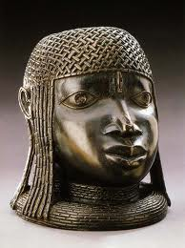
Memorial Head Benin. Early Period,
c. 1400-1550 ce. Brass 9”

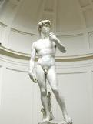
David, Michaelangelo, c.
1500-1504 ce. Marble, 16’

Archaic – Alligned Contraposto- Unalligned sculpture
O’Keefe- first renowned female artist
Naked vs. Nude Nude is educational usage like in pieces of art.
FORM
Line and Shape
Color
Texture
Space
Mass
Composition

All art has content but not all has art subject matter
Medium is what art is made of
Altamire Spain- 1st wall paintings. Glascow FR confirmed them

