Chapter 2

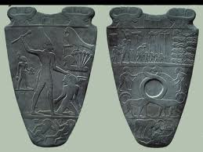
Two cow heads on left representing Sky god Nut.
Head on land with Papyrus strings coming out. The bird represents pharaoh showing that it controlled Upper Egypt
Tail of Bull=Sign of strength

Palate of Narmar

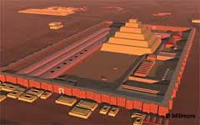
Djoser Saqqara
Built of Stone
Made to last forever
14 fake entrances (made to resemble palace)
1 real one
Imhotep – 1st main architect of history
Name on tablets throughout temple saying he is the mastermind of

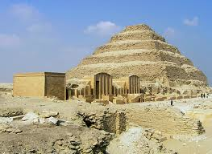
Funerary Complex of King Djoser, Saqqara.
3rd Dynasty c. 2681 – 2662 b.c.e. Limestone
Fake temples to the left of Saqqara
Life size seating statue of Djoser in Serdab (a room with a statue in it)
Statue ensured he was present to enact rituals shrine required
FACED STARS
Imhotep – 1st main architect of history
Name on tablets throughout temple
Deified by Egyptians and was a Genius
Similar to a Ziggurat because it has tiers
By Fourth dynasty architecture went from Saqqara’s to Pyramids

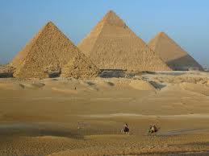
Sneferu built Pyramids built stepped Pyramid. Not the Great Pyramids. Then changed stepped ones to smooth one.
1st smooth one
The Great Pyramids of Giza (Best known)
Built for Khufu (1st and Largest), Khafra (2nd and medium size), Menkaure (smallest/last)
Medium – 450 ft. tall
Equilateral triangles. Mathematic perfection
Plated in Gold at the very top
Everything in pyramids anything under=fake
All Pyramids enclosed by wall with things inside the walls for pyramids.
Burial Hierarchical Scale with king in pyramid and high preist/ family around it
Pyramids/ Burial Sights on West side of Nile=side of setting sun faced towards stars
FACED SUN different from King DJoser’s North/South Saqqaras
Sun is most important now while Saqqaras focused towards stars
Benben was sacred stone shaped like pyramid that represents mound in Egp creation
Funerary architecture shows shift to West side of Nile shows ruler viewed differently. Emphasized Pharaohs solar aspect with the Sun god (Ra) While this is happening Egyptians are calling pharaoh the son of Ra. In past he was associated with Horus. Pyramids turned into tombs instead of little palaces.
Sun= Ra being reincarnated every day.
Pyramids show Pharaoh to be reincarnated with Ra every day on the sun’s rays
Head of Sphinx is believed to be Khafra
Islams were uncomfortable with human representaition of god so the broke its nose.

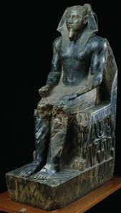
Sculpture of Khafra, c. 2500 BCE. Diorite, 66”
23 sculptures made=very proud of himself
Mummification building on Nile and then would bring straight to pyramid
Rigid seated forward. Shows permanence/ strength.
Face shows eternity
Open hand=reaching for offering ********
Closed hand=representing authority
Like palace of Narmer, it expresses kingship
Hole in chin to stick stuff through tongue and out hole
Falcon behind head=Horus is still part of Pharaoh.
Falcon deifies him and shows him as Horus on Earth.
Shirtless to show he is jacked the fuck up
Nubia Diorite from there South of Upper Egypt.

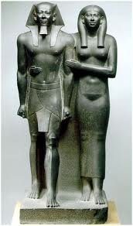
Menkaure and His Wife(Khamerernebty), c. 2540 BCE. 4th Dynasty

Archaic but associated with Greece not Egypt
To be viewed from the front
¾ life size
intended location explains frontal view. People looking out from a temple against wall
sculptures unified because of all their similarities
One is draped one is half nude. Women is draped; man is half nude
Possible traces of paint have been found
Left foot forward represents divinity

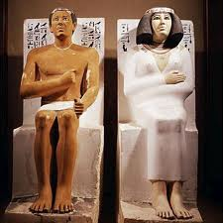
Prince Rahotep and his Wife, Nofret. C. 2580 bce, painted limestone. 47.5”
Has a mustache
Softer than limestone so couldn’t get as much detail
Ma’at – Balance and Harmony
Women – “dependent of the king”
Man – Government official
Precious stones put in eyes to make them appear real
Frontally posed with ritualized gestures
Viewed in the round – 3D to be viewed from all directions
Rigid Postures – Eternal/strong

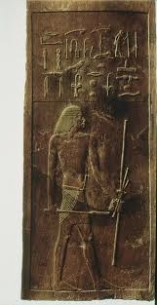
Relief Panel of Hesy-Ra, Saqqara. C. 2660 bce. Wood 45”.
Proportions
5th dynasty – proportions are the same across all art

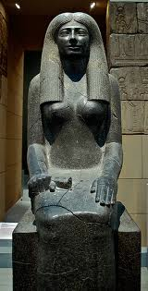
Sculpture of the Lady Sennuwy

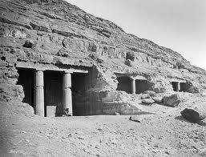
rock cut tombs at beni-hasan

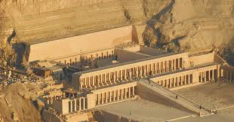
Hatshepsut’s Temple, Deir el-Bahri c. 1478-1458 bce

Regent of Thutmose III
Hatshepsut ruled for him since he was 8 when father died
Made big shit to assert power
Temple harmonizes with cliff
Myrrh trees lined Temples
Hatshepsut led caravan to Punt to get Myrrh trees. She herself led the expedition
Punt is just NE of Nubia
Moral of Thutmose I giving her his power

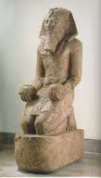
Kneeling Figure of Hatshepsut, c. 1473-1458 bce. Red Granite, 8’6”
1 of 8
Portrayed as man a lot since Pharaohs were men
Still portrayed as women at times
Fake Beard
No breasts
Offering of two jars. Gudea Water of Lyfe Cause she bout it.
Kilt of Pharaoh’s
Thutmose III’s temple is next to his mother’s and he hates her for ruining his life. Scratched out her name on stuff. Tried to take over her temple.

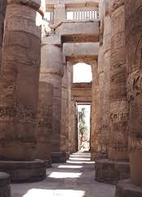

Hypostyle Hall of Temple of Amun-Ra. Karnak c.1290-1224 bce.

There were three gods that the Thebians followed- Amun, his consort Mut and their son Khons. The temple was devoted to them. There were several pylons that over time were devoted to different kings.

Domination Architecture
Hypostyle Hall- Great hall full of Columns
Obelisks- tall monoliths/megaliths
Sacred Lakes used for Cleansing.
Regular people couldn’t go through the Hall but Priests and Pharaohs could go into the Temple
Slaves could not go into Hypostyle Hall
Columns of sunken relief

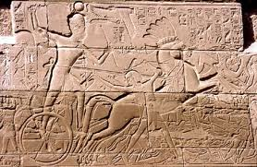
Seti I’s Campaigns, Temple of Amun at Karnak, Thebes. c. 1280 bce Sandstone, Sunken Relief
-Preserves smoothness of rock.

Killing Lion’s – Basically same thing
ESSAY – Assurbanipal Killing Lions

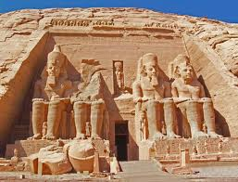
Temple of Ramses II, Abu Simbel. 19th Dynasty, c. 1279-1213 bce
Ramses II made more architectural stuff in EgyptiAN history
Dedicated to Amun; Ra; and Ptah
Big guys in front – Ramses II
Claims Ramses controlled Kush
Kush wealthy source of Ivory animal pelts, gold, and Diorite
This temple is a Façade
Image of sun god behind him. Falcon head with sun above his head
Ramses on each side of sun god to show him giving balance to the people and receiving his power. Pharaoh is keeper of order on earth from request of gods.
Size and frontality show something about priests inside.
Receiving Ma’at from Ra giving him power

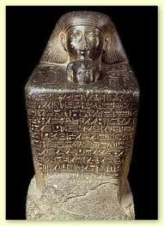
Has hieroglyphics
Became common in New Kingdom
Abstract form of guy sitting with knees up to chest, arms around it, and wearing dress
Literally forms block
Tutor of Nefrua (Thutmose II Daughter)
Second smaller head of Nefrua
Shows Senenmut with hands around Nefrua

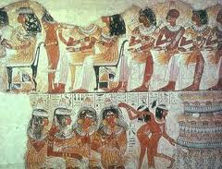
Musicians and dancers, frasgment from Nebamun, 1350 bce. 24” Clay/ plaster and paint
Composite – frontal view of chest and shoulders side view head and legs
Two naked girls are not royalty because of their relaxed posture
Hieratic Scale
REGISTER
Jars indicate wine was plentiful
Full frontal faces on bottom
1st frontal face we have seen
Ma’at
Royalty always portrayed rigidly

Amarna Style -
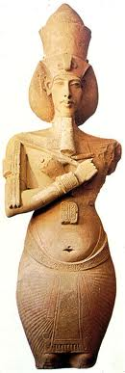
Sculpture of Akhenaten, from Karnak, Thebes. 1353- 1335 bce. Sandstone, 13’
Guy would have had pot belly and neutral face(man or women)
Aten – god that had to do with regeneration
Akhenaten wanted to be portrayed as Aten.
Large lips, narrow eyes, nose – allows people to know its Akhenaten
Two hands holding Flail and Sheppards Crook/Staff – depicts PH

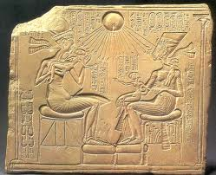

akhenaten and his family. C. 1355 bce. Limestone, 12”x15”
Sunken Relief
Literal representation of regenative properties
Before this, children portrayed as little adults.
More life like

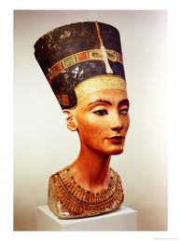
Sculpture of Queen Nefrertiti. C. 1348-1336 bce. Limestone, 19”
Unfinished right eye
Master sculpture of Nefrertiti
Most sculptures and pictures of Nefrertiti were based off of this
Not armana Style

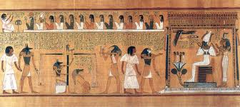
Weighing of the Heart and Judgement of Osiris, 1285 bce. Painted Papyrus, 15”
Register
Anubis second from left holding circle cross. Dog head
Not a Pharaoh – no Crown
Crocadile, dog, lion thing eats heart if bad
Thoth just to the right of scale. Ma’at represented on top of scale
Guy before him is going to heaven. Horis with falcon face. Bird holding ostrich feather shows fair judgement next to Osiris.
Ankh – circle cross sign of Reincarnation

Upper Egypt – Red Land
Lower Egypt – Black Land (Fertile soil of Nile Delta)

Peasant art doesn’t exist anymore

Egyptian Canon- Consistent use of proportions and style used in portraying human image
It was used for upper echelons
Lower status more relaxed/natural

