Frying Pan,” from Chalandriani, Syros. Early Cycladic II. Ca. 2500 – 220 BCE

Figure, from Cyclades. Ca. 2500 bce. Marble 16”
Arms folded toes extended
Traces of paint

Harpist from Amorgos, Cyclades. 2500 bce. 8.5”

Reconstruction of the Palace Complex

Capital is the top of a column
CUSHION, TAPERED DOWN,

The Queen’s Megaron, ca. 1700-1300 bce, from Knossos, Crete.

Spring Fresco. Fresco from Akrotiri, Thera ca. 1600- 1500 bce

Octopus Vase, stirrup jar from Palaikastro, Crete. Ca. 1500 bce.

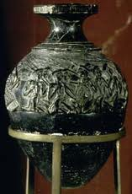

Harvester Vase, from Hagia Triada. Ca. 1500-1450 bce. Stone/Seatite, 4.5”

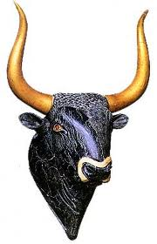
Rhyton in the shape of a Bull’s head, from Knossos. Ca. 1500-1450 bce. Serpentine, steatite, crystal, and shell inlay (horns restored). 8”
Hole in the bottom which is a characteristic of Rhyton’s
Painted eyes crystals
Used to portray Minoans
Horns made of gold
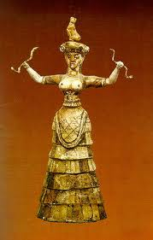
Snake Goddess, from palace complex, Knossos. Ca. 1650 bce. 11”

Snake goddess
Worshipped on mountain tops because no
Flounced dress
Snakes associated with earth diety and Man fertility
Cat on top of head
Skinny waist=representaition of all Minoans
Found in burial pits

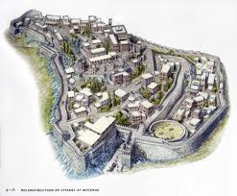
Mycenae Citadel
Mycenaians are war like
Minoans were peaceful

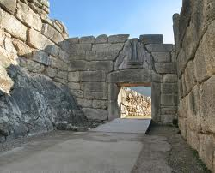

The Lion Gate, Mycenae, Greece ca. 1250 bce. 10’
This is a Corbeld Arch
Lions on top of arch are Heraldric
1st large scale structure on the Greek Mainland

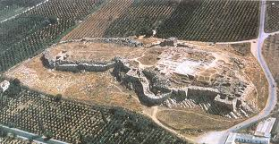
Tiyrns Citadel
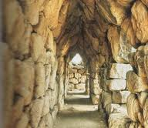

Corbeled Casemate at Tirtns, Greece. Ca. 1400-1200bce.

A casemate is a room for storage or shelter during attack

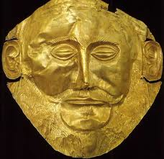

Mask of Agamemnon, Mycenae. Ca. 1600-1500 bce Gold, 12”h

Asshole German found this. Is not Agamemnon
Many were found, however, they weren’t specific. The masks looked like the person they belonged to.

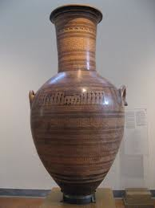
a

GREEK ART

Late Geometric Belly – Handled Amphora “Dipylon Vase.” Ca. 750 bce. 5’1”

Very big and rich people commissioned it
Bc of the shape we know this is a women’s burial Amphora
Funerary Vessel

Meander “Maze” – Trickle meander is at the top

Women laying down in shape of triangle
Arms of because they are lamenting/mourning

Prothesis
Mathematical emphasis into vases

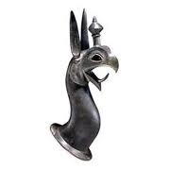
Griffin-head Protome from Bronze tripod Cauldron, Rhodes. Ca. 650 bce. Cast Bronze

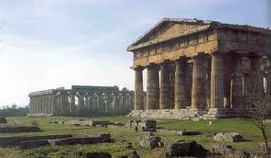
The Temple of Hera I. ca. 550 bce,
Temple of Hera II ca. 500 bce

Bottom third of temple the shafts swell
Hera II best preserved Doric temple of all time

Kore and Kouros – Stone Sculpture (GRANT)

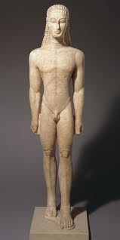
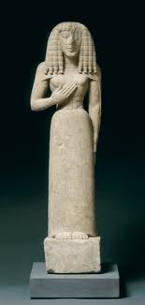
Kore (maiden). Ca. 630 bce 24”
Negative space could see through
Arms. Egyptian on giant slabs
More stylized earlier it is
Both Standing on own two feet
Carved out negative space between arms and feet
Only Wealthy commissioned these
Large stylized eyebrows and big eyes
Fully nude
Women could NEVER be fully nude
Kouros (youth). Ca. 600 bce. 6’
Left foot forward because they copied
Greek exactly. No idea what these were used for. People thought Kouros was Apollo
ARCHITECTURAL SCULPTURE. Archaic Style^^^ very egyptian

Reconstruction of the Temple of Artemis at Korfu, ca. 600 bce.

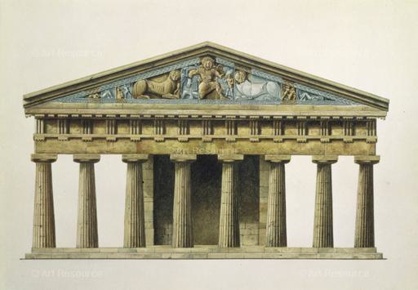

Recognize Medusa
Pediment is decorated with triangular sculptures
Size in pediment was dependent on open space
Carved behind sculpture to make each piece look like a separate sculpture
Medusa was a guardian figure or to show Artemis’ control over nature on Artemis’ Temple. Lions on each side of Medusa. Pegasus came out of Medusa’s neck (her son)
Chrysaor other son of Medusa. Medusa’s two sons on either side of her.
Synoptic narrative – inconsistency with a known story. Her two sons came out of the death of Medusa (when her head was cut off)

Carytios – statue forming a column

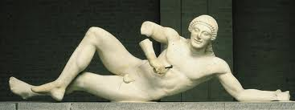

Dying Warrior, from the west pediment of the Temple of Aphaia. Ca. 500 bce. Marble, 5’2”
Late Archaic
Original Eastern Pediment was destroyed by Persians when they attacked Greece which was later replaced
Both pediments showed epic battles of Troy

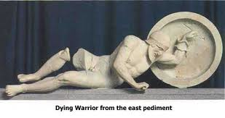

Dying warrior of the east Pediment of the Temple of Aphaia. Ca. 480 bce. Marble, 6’
More realistic
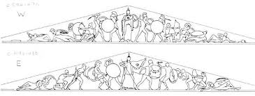

Reconstruction Drawing of the east pediment of the Temple of Aphaia
Athena overwatching the battle between Greece and Troy
Figures faced towards Athena attracting eyes to the center

Death poses aren’t awkward anymore. They were more realistic and natural

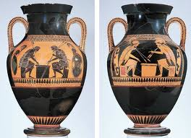
Achilles and Ajax Playing Dice. Black-figured Amphora. Ca. 540-530 bce. 2’
Profile View
Asymmetrical but not mathematically exact
Hunched over=into the game
Left saying = 4
Right saying = 3
Achilles winning is ironic bc achiles dies the net day

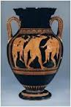
Euthymides. Dancing Revelers.” Red-figured amphora. Ca. 510 bce. 2’
Not Profile View Shoulder Blades raised with arm. NEW
-because they are learning about Anatomy
Wrote taunt on thing “As never, Euphronios”

THE CLASSICAL AGE

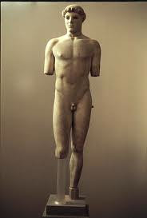
Kritios Boy. Ca. 480 bce. Marble. 46”
Engaged leg is the leg that supports weight
1 of the 1st contrapposto statues ever found
Arrested walk – stiff, rigid, firm psoe
Right hip thrust downward
Not Archaic.
Dawning of a new age
Seems capable of action. Like he cold continue to walk

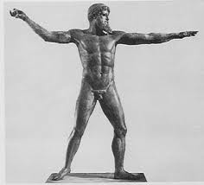

Zeus or Poseidon. Ca. 460-450 bce. Bronze. 6’10”
Shows portrayal of him throwing thing but solid, firm stance on ground
Solid bronze
Because it was bronze he could maintain this pose over time

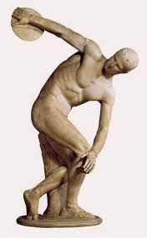

Diskobolos (Discus Thrower). Roman Copy after a bronze original of ca. 450 bce by Myron. Life Size

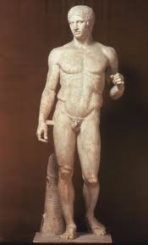
Doryphoros (Spear Bearer). Roman Copy after an original. Ca. 450-440bce by Polykleitos. Marble. 6’6”
Proportionatly and mathematically perfect.
Unknown Greek writer called this style Kanon
Polykleitos – more philosophical than religious
On border of Ideal and Mathematical perfection

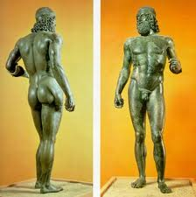
Riace Warrior A. ca. 450 bce. Bronze 6’8”
Found underwater
Glass and Ivory eyes, bronze eye lashes, copper nipples and lips, and silver teeth
Employed various textures to play off the light

ARCHITECTURE & SCULPTURE ON THE ATHENIAN AKROPOLIS

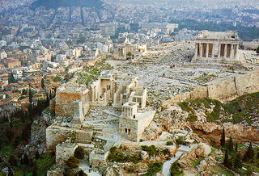
AKROPOLIS, ATHENS
Nashville, TN recreation of Akropolis. 1-1 recreation(exact)
Temple of Athena only thing to be completed before Peloponnesian war
“Adorned city like Harlet costing 1000 Talents” –Pericles
Delian League funded it
Talent – Measurement of mass similar to amount of water that it took to fill an Amphora.

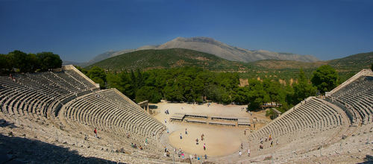
Theater, Epidauros. 3rd – 2nd Century, BCE
Made theater in side of mountain because background is bombass

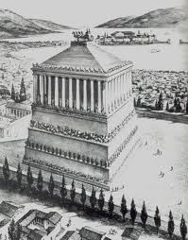
Mausoleum at Halikarnassos. Ca. 359 – 351 bce
Giant temple. Satrap was buried there.
Satrap Mausolos – title of the governor buried there

13th century earthquake broke top of building
Ionic columns on top. Set on high podiums with high pyramid on top
Egyptian Pyramid
Local Lycian Podium
Greek Classic Ionic Columns

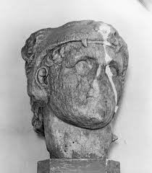

Head of Herakles or Telephos. Ca. 340 bce. Marble, 1’
Know its Heracles because he is wearing a Nimian Lion on his head
Fleshy face and smooth plains of face are hallmarks of classical art.
Aspects add drama and emotion
Lips open slightly, tilted head, deep eyes, and sagging eye brows

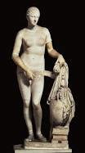
Aphrodite of Knidos. Roman copy after an original of ca. 340-330 bce. Marble 6’8”

1st nude sculpture of woman in Greece
Know its Roman because the support structure.
Not wearing shoes
Original pornography

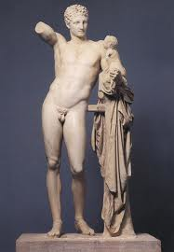
Hermes and Dionysus, Roman Copy after an original of ca. 320-310 bce by Praxiteles. Marble. 7’1”

Arm was up and bent holding grapes and baby was reaching for grapes.
Dionysus was god of wine and theater
Polished shiny, texture of hair. Great quality
Anatomy is blurred to suggest youthful appearance because he wasn’t ripped

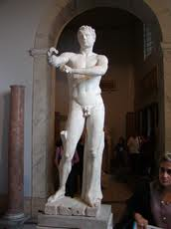

Apoxyomenos (scraper). Roman marble copy after bronze original of ca. 330 bce by Lysippos. 6’9”

Scraping to clean oneself. Late classical art

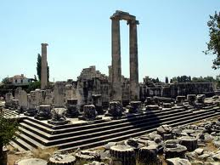
Temple of Apollo. Didyma, Turkey. Begun 313 bce.
Built on archaic temple ruins destroyed by Persiana in 494 bce
Exterior looked like any ionic temple of time
Inside wasn’t an ionic temple
Cella was raised 5 ft off ground and inaccessible
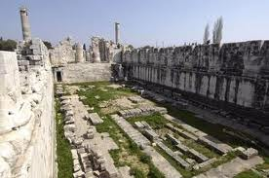
Allegory of the Cave
2 tunnels on each side of temple.
Stairs that go up to nowhere all around temple
Courtyard is very open showing people could go there with altar raised on other side
Shallow etchings. Blueprint for building the temple

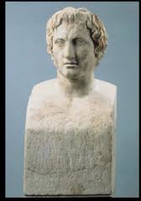

Portrait of Alexander the Great, by Lysippos. Marble 27”. Roman copy after original
Lysippos is the only one to make these
Similar to Egyptian block statues
Alexander started portrait movement
Knew there was a need to have constant visual reminders of himself

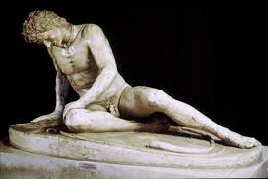
Dying Trumpeter/Dying Gaul. Roman copy of a bronze original of ca. 230-220 bce. Marble. Life Size
Torque around his neck to let us know he is from Gaul
Has facial hair and his hair is not greek-like
Hellenistic sculpture because he is dying
Dying alone so he is looking down.
Right under left peck and there are drops of blood carved out
Enemies in past are displayed as weak. This guy is dying nobly. Venerating their enemies, venerates them.

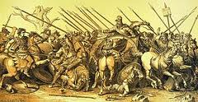

The battle of Alexander and the Persians/ The battle of Issos
Period of Hellenistic Greece, wall paintings were done in four colors: Red, Yellow, Black, and White
Mosaic is faithful because of the colors

REVIEW

Aegean Sea This sea, between Greece and Turkey, was a hotbed for both wars and cultures during time

3 cultures predominantly comprise Aegean art – Cycladic, Minoan, and Helladic

“Frying Pans” found on the Cycladic Islands were most likely used for Palettes for Cosmetics

B for votive idols found in the Aegean art were thought to have been used in life as well as being buried with the decreased

The Palace at Knossos was build by the Minoan Civilization at Crete

Palace at Knossos is likely a Misnomer, because The structure housed Granaries, Workshops, and store rooms

The Haphazard layout of the palace layout of Knossos was likely defensive move, as the palace had no exterior fort and the inspiration behind the

Minoan columns are unique because they had cushion like capital, oval-shaped, painted black, red, and white, and tapered down to narrow base

Minoan wall paintings frequently featured sea-life and water

Minoan wall paintings were most often painted with pigments found naturally on the island because it was red, white, and black

The Aegean Octopus Vase is a Stirrup Jar because it has the two loops or stirrups

The Harvester Vase is likely influenced by Egypt

If you saw Egyptian relief carvings with figures carrying bull-headed rhytons, you would know it represented which nation? Minos

Religious life on Minoan Crete centered on Natural sites, such as mountains, caves, or groves of trees (Snake Eyes)

The Lion Gate was: A corbelled Gate, the principle entrance to the citadel of Mycenae, The first large, scale sculpture built on the greek mainland

Sources of Greek Art come from: Literature, Original Works, and roman copies of Greek Originals

This style of greek art is decorated with checkerboard patterns, meanders, concentric, circles, triangles, and other simple designs is known as Geometric Style.

Certain vessels, such as dipylon vase, were used as grave markers – specific shapes were associated with the sex of the deceased. Females buried beneath Belly- handled amphorae. Males – neck amphorae

The Dipylon Vase’s size indicates: the Deceased was considerably wealthy.

The Chronological order in which the following were developed is: Doric, Ionic, Corinthian

A Cella is: The central chamber within a Doric or Ionic temple and the Central feature within a Peripteral Temple. Peripteral – style of Temple (Doric and Ionic temples).

An entablature consists of all horizontal elements across a Peristyle

Free-Standing scultures, with no back-slab, utilizing negative space (between arms and legs), large eyes, and arched stylized eyebrows are all qualities of what kind of sculpture: Archaic Sculpture

The following have Volutes: Ionic Coplumns and Doric Columns

The Greek Cella is likely a descendant of: the Mycenaean Megaron

The temple of Hera I & II are fine examples of: Ionic Temples and Entasis

Generic Greek figures in the Archaic period are called core and Kouros. These words mean: Maiden and Youth

Archaic stone sculptures is heavily influenced by: The techniques and proportions of Egypt

On the Temple of Artemis at Korfu, the main figure on the pediments ia The Gorgon, Medusa

The Temple of Aphaia at Aegina has sculpture on its pediments, the figures are: Independent of the pediment, completely detached and creatively placed so as to fill the unique shape of the pediment

A symposium was A philosophical event, a chance to debate with colleagues, centered around a krater, drinking wine, and probably pretty awesome (Gay butt sex)
On the black-figured amphora made by Exekias, the scene depicted shows: Achilles beating Ajax in the game of dice, with words projected form their mouths

The Kritios Boy is significant because: first known statue that stands entirely on its own and first usage of controposto pose

The sculpture of Zeus/Poseidon can only have been made of Bronze because his arms are outstretched, throwing a thunderbolt/trident. The arm is made of bronze allowing it to be outstretched

The Riace Warriors have Ivory eyes, silver teeth, and copper nipples

To see the Parthenon you need to go to Athens, Greece or Nashville, Tennessee

The Parythenon was goveren, so as to make it mathematically perfect / harmonious. By an architectural ration of 9/4

The Late Classical Period was defined by a shift toward: Structural emphasis and Corinthian Order

We get the word Mausoleum from: a Lycian Tomb

A good example of Theatrically in architecture lies in, Temple of Apollo

Theatricality in architecture is best described as Providing a revelation or epiphany to a visitor

Hellenistic sculpture includes: viewer involvement in art/ arch, heightened drama, an interesting portraiture

With sculptures such as the Dying Trumpeter or Aphrodite of Knidos, we as the viewer are compelled to watch, drawn into the scence

