ETRUSCAN/ VILLANOVAN ART

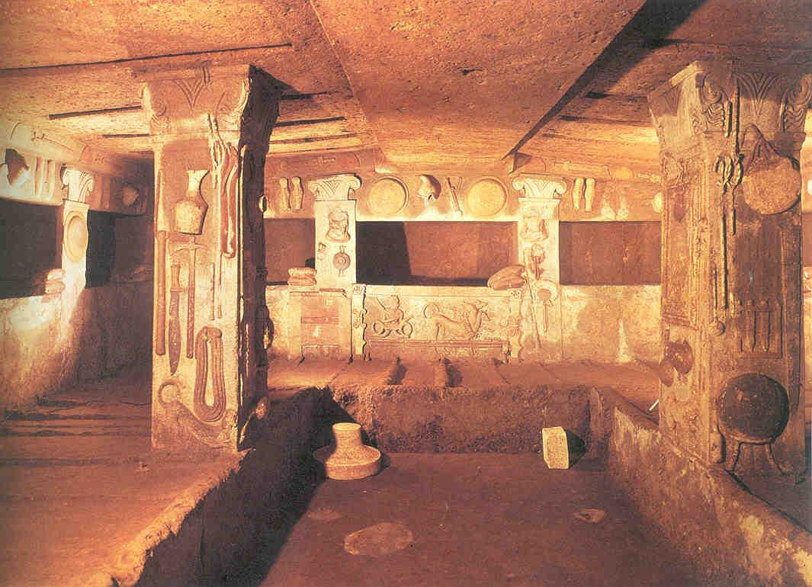
weapons, tools, cats, dogs, and humans relief on the wall.

Made to look like someone’s home

Idea of things were sufficient for Etruscan’s

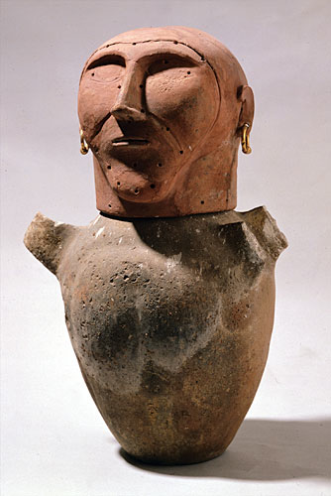
Human Headed Cinerary Urn. C. 675 bce. Terra Cotta, 25.5”
Dead person’s ashes were put in these

Elevate Urn and believed soul was still in the urn

Raised on throne to show higher status
Earing for decoration and probably was painted

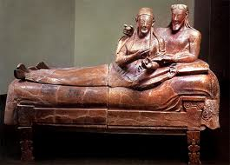
Sarcophagus from Cerveteri. C. 520 bce. Terra Cotta, 6’7”
Were holding items.
Made in the round despite rigidity
Once painted and is still archaic

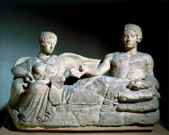
Youth and Female Demon. Cinerary Container. Early 4th c. BCE. Stone, 47”
Left is a demon and it has wing
Demon is any celestial being
Record of his fates and she is judging him
Man is reaching for scroll in her lap
Balanced in that there are two structures on either side but man is alone in his urn despite being buried around family
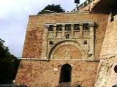

Porta Marzia. 2nd c. bce
Romans said Etruscans were masters of architecture, city planning,
Romans borrowed draining and aquaducts from Etruscans
Built predominantly with wood or mud so not much has survived
Best known example of surviving large structure
Porta is door. Part directly above door is Etruscan
Voussoir – stone part of arch at the bottom
Engaged relief sculpture and piliasters (nonfunctional; strictly decorative)
Top part is an Entablature which shows they had contact with over Mediter. People
Tinia and his sons are the relief structures. Tinia was Etruscan Zeus

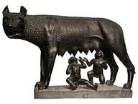
She-Wolf. C. 500 bce. Bronze, 33”
Original didn’t have Romulus and Remus
Two boys were added by Romans in the 15th century
Riace Warrior had texture in hair like wolf does on neck
Etruscans were known for their bronze and Terra Cota works
Romans prized this more than the Etruscans

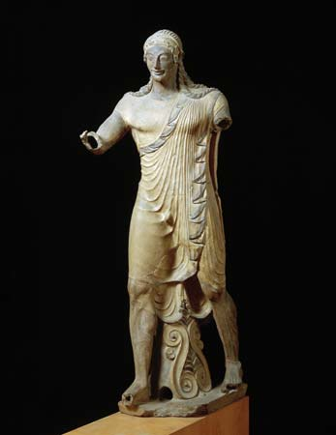
Apollo from Veii. C. 510 bce. Terra Cotta. 5’9”
Volute in between legs
On Temple Ridgeline
Etruscans frequently had structures there. These structures together made a story
Hollow because it was made of Terra Cota which is similar to clay

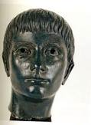

Portrait of a Boy. Early 3rd Century bce. Bronze, 9”
Smooth skin, bushy eyebrows, and straight hair
Explored full range of textures. Straight hair was different from stylized curly hair

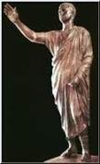
Aule Meteli (L’arringatore – Orator) Early 1st c. bce. Bronze, 71”
Arm extended shows he is an orator
Craftsmanship is clearly Etruscan
High boots are clearly Roman
Still Etruscan man but might be influenced some way by Rome

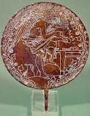
Engraved Back of a Mirror. C. 400 bce. Bronze, 6” Diameter
Backs of mirrors used to carve images of Etruscan versions of Greek Myths.
In the Illiad, this guy was a fortuneteller. Etruscans put a Seer on the back of a Mirror. Looking at Liver of Augury to see future.
This is a roman official

ROMAN ART
Art commissioned by wealthy people in order to make themselves look awesome

ARCHITECTURE
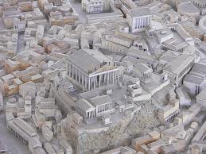

Temple of Jupiter Optimus Maximus

Place of veneration
Temple was started by two 6th century by Etruscans
Etruscans literally started Rome
Started by Tarquinius the Proud and Tarquinius the Ancient
Ionic
Frieze on top made of bronze
Has three Cellas which makes it unique
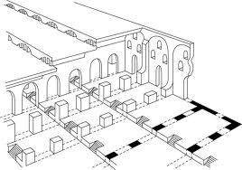
Porticus Aemilia, Rome. 2nd C. bce
Made of concrete. 1 st one
480,000 sq ft

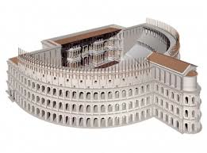
Theater Complex of Pompey, Rome. 55 bce
Remarkable bc it is not built on an existing slope. Made artificial one out of concrete
Concrete made it possible to build wherever they wanted. Didn’t need a hill
Hierarchal seeting arrangement. Rich at the bottom
A lot of seats

Statue Base of Marcus Antonius. Early 1st C. BCE. Marble.
Portraying census and everyone paying taxes.
Statue of Mars in the center showing that he is
Mars there shows that the census has to do with military
Left side is beginning right side is end. This is called Synopsis
On all three registers above census there is Neptune marrying a sea nymph
Bottom register is very rigid; top three are very Hellenistic

“Greece, Having been conquere, her wild conquerer, and brought the arts into rustic Latium.”
-Horce, Poet

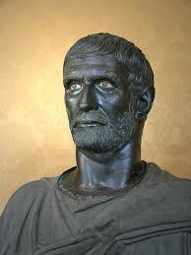
Brutus. Early 3rd C. BCE. Bronze, slightly over life size
Not Brutus
Not a youthful ideal power figure.
Looks strong, powerful, and stern because his aged faith (Romanized)
Downward tilt of head suggests may have been on larger statue w/ him on horse
End of second century bce where most Roman portraits were made
This is a Veristic/Realistic statue

Veristic Male Portrait. Early 1st c. bce. Marble, Life Size
Probably a senator.
Portrait’s were made to get face out there.
These distinguished faces showed they would be good leader

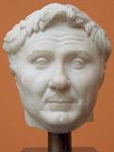
Pompey. Copy of a portrait from 50 BCE.
Realistic portrayal of Alexander the Great/ Warner Moore’s hair

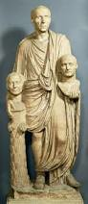
Togate Male Portrait with Busts. Late 1st century bce. Marble, Life-Size
Freed slaves would

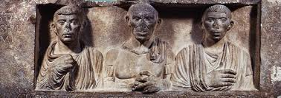
Funerary Relief of the Gessii. C. 50bce. Marble. 25x80”
Freed slaves would chip in and have portrait made
Slaves put their names on statues

NOW IN EMPIRE WHICH BEGAN WITH OCTAVIAN
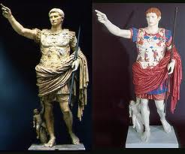
Augustus of Primaporta. Possibly a Roman copy of a statue of 20 ce. Marble 6’8”
Rome is next step in level of development

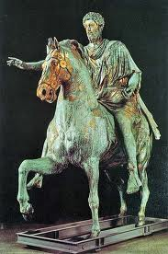
Equestrian Statue of Marcus Aurelius. 161-180 CE. Bronze, over life-size

Christians thought this was Constantine who brought Christianity to Rome, so they didn’t melt statue
Statues had more abstract style
Hand is out in mercy
Horse’s leg was on top of dying barbarian
Has beard to show wisdom
Military cloak depicts him as military general
Propaganda to show his traits that were ideal for general

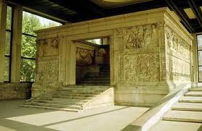
Ara Pacis Augustae (Altar of Augustine Peace) (West Facade). 13-9 bce. Marble, 35’
Practice of narrative relief went long into Republican Empire
Reliefs were put on public monuments for eryone to see
Memorial to peace after Augustine beat everyone in Gaul and France

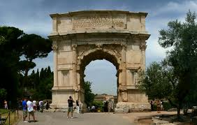
Arch of Titus, Rome. c. 81 ce. Marble Freestanding
Erect arches where they won battles. Oldest one in rome.
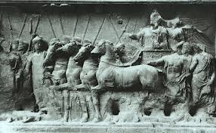
Led nowhere. Relief sculptures of soldiers carrying
Both processions are going same way which involves the real people moving through
Lady behind Titus crowning him
Honor, Virtue, and Victory are accompanying Titus on sculpture
Inclusion of three personifications and lack of Vespacian shows Titus was supreme ruler
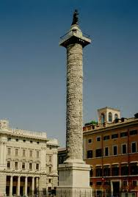

Column of Trajan, Rome. 106-113 ce. Marble, 125’
656 feet of register that wraps around and spirals up
Conquering of Dacians by Trajan
Trajan is burried inside of this
Many scenes are repeated several times as it sprials up
150+ episodes in register

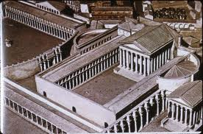
Forum of Augustus, Rome. 2 bce
Caryatids are statues used as columns
Rectangular portico area with temple inside

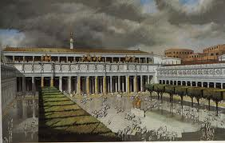
Forum of Trajan, Rome. Restored View
Had statue people holding forum up
Built on wealth and success from Dacian War
Form wanted to show that wars were good with wealth

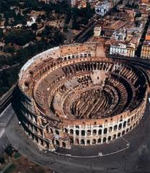
Colosseum, Rome. 72-80 ce
Vespasian commissioned the Colosseum
Colossus right next to it so that’s how it got name
100 days of games after they finished it
9000 animals died in that time
arena held 50,000 people
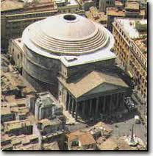
4 layers represent 4 architectural layers. Etruscan/ Doric on bottom layer. Ionic on 2nd layer. Corinthian on 3rd layer. Top=Pilasters which is column modeled into the wall

The Pantheon, Rome. 117-125 ce.
Theo=gods pan=all
Best preserved pagan temples in Rome
Image would have led to a rectangle cella inside after seeing the front
27 ft wide hole in the top. Couffers are panels that are surrounding the hole. Center of couffers is not centered. Looks centered if you are in the center of room
Dome and Drum are the same height. Height and width are same height
Sphere or circle associated with eternity/perfection
Dome doesn’t line up with drum = illusion looks like dome is floating on drum
Renaissance era scholars found faults because nothing lined up
Hadrian held his court here. 7 Alcoves – recessed areas in the walls\
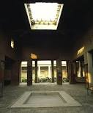
Atrium of the House of the Vettii. Pompeii, 2nd c bce – 1st c ce
Roman houses had central rooms with hole in the ceiling to catch rain water
Painted wall represented wealth. Roman wall paintings had 4 styles
-paint on wet plaster to make walls look like fancy marble (marble imitat.)
-architectural elements and figures. Crazy architectural fantasy.
-flat areas with bold color and architectural elements
-Combines all three previous styles

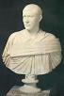
Portrait o Philip the Arab. 244-249 ce. Marble sized, life size
Rose to power and had a statue made of him quickly bc emperors didn’t last long
Diocletian restored empire after civil war. Divided power from one emperor into 4 emperors = Tetrarchs = 2 majors and 2 minors
Juniors were Caesars
Terms were limited

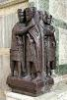
Portrait group of the Tetrarchs. Ca. 305 ce. 51” h
Moved to Venice and is on the corner in St. Marks Square.
Porphyry made of – purple marble from Egypt used specifically for tetrarch sculp.
Likely originally of co lumn
Power of office came from office not individual. Shown through no distinctions
All shared power and looked alike in sculpture to show shared power

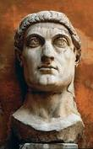
Portrait of Constantine the Great. C. CE. Marble, 8’
Constantine vs. Maxentius @ Milvian Bridge – Both fought to see who would become emporer. Constantine saw a Celestial phenomenon where he saw the P with a X
Eyes were big because they wanted to see the eyes even though they were 60’ in the sky
Size links himself with Trajan and Augustus

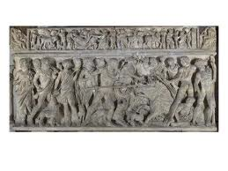
Meleager Sarcophagus. Ca. 180 CE. Marble
Emporers were still cremated but most wanted to be buried in tact
Started making marble sarcophagi covered in relief sculpture
Most showed Roman mythological scenes
Depicting Meleager hunting the giant Bore
Not controposto because of guys ass

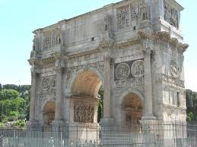
Arch of Constantine. 312-315 CE
Almost everything was taken from other Roman statues
Dacians on top standing out are from Forum of Dacian

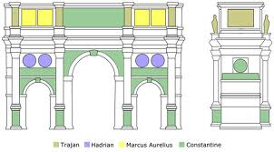

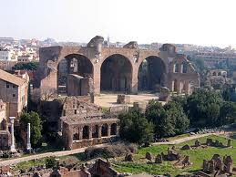
Bathouse of Caracella. 700’ by 400’

Bascillica of Maxentius. 307 ce
Basileus – Greek for King
Constantine put portrait on Western Apse – Recess or cave

Palace of Diocletian. 300 CE. Diocletian started tetrarchy
Fortified because its far from Rome

Each ruler in tetrarch had section of Rome that they controlled

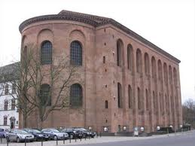
Basilica of Constantius Chlorus (father of Constantine)
4th century ce
Classical architecture is now done
Huge departure from classical architecture
Giant square empty room with Coffered Ceilings (Pantheon)
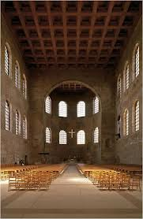
Windows in the Apse are significantly smaller than others which makes it appear much longer
The Emporer in Apse would appear larger because of this

Veristic Male Portrait. Early 1st C. BCE. Marble, Life Size
Good example of Veristic art

Villanovan

Settled between Florence and Rome originally

Called room of relief because everything is fake and resembles items which shows that dead don’t need real items just representations. – pull this tomb and Egyptian room together

60-80 multiple choice
10-15 picture identification just picture

Apollo of Veii Etruscan Art

Porta Marzia

Pilaster –

She-wolf is stylized not realistic
Portrait of a Boy – Realistic

Engraved back of a Mirror

