AP Art History Chp. 5

Don’t worry about combination of basilica and central

Mosaics: Decorating Walls
Tesserae – Tiles used to make mosaics

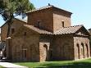
Mausoleum of Galla Placidia, Ravenna. 425-450 ce.
Greek Cross which is a central style
Has equal arms
Exterior made of bricks -
Inside is very intricate - Similar to life of Christian modest outside intricate inside
Above every vault there are two apostles, two doves, and a fountain symbol of water of paradise
St. Lawrence in a Lunet with his whole story. Material wealth of church is what he is protecting. Has grill to show how he died
Good Shepherd Mausoleum – actual landscape sets him into real life
Gold Halo comes from deification of previous sun kings of previous empires (Rome)
Golden robe, purple scarf, and gold halo gives him power of emporer
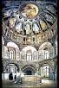
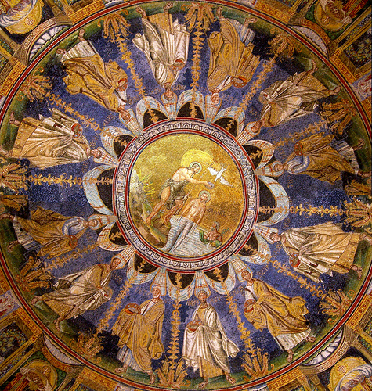
Orthodox Baptistry, Ravenna (Interior)
Place for public baptisms only on Easter Sunday at Midnight
No longer had to baptize is private
8 sides are symbolic of life, death, and resurrection
Ceiling of Baptistry 12 apostles around Jesus being baptized by John the Baptist. Pagan River god behind the Baptism

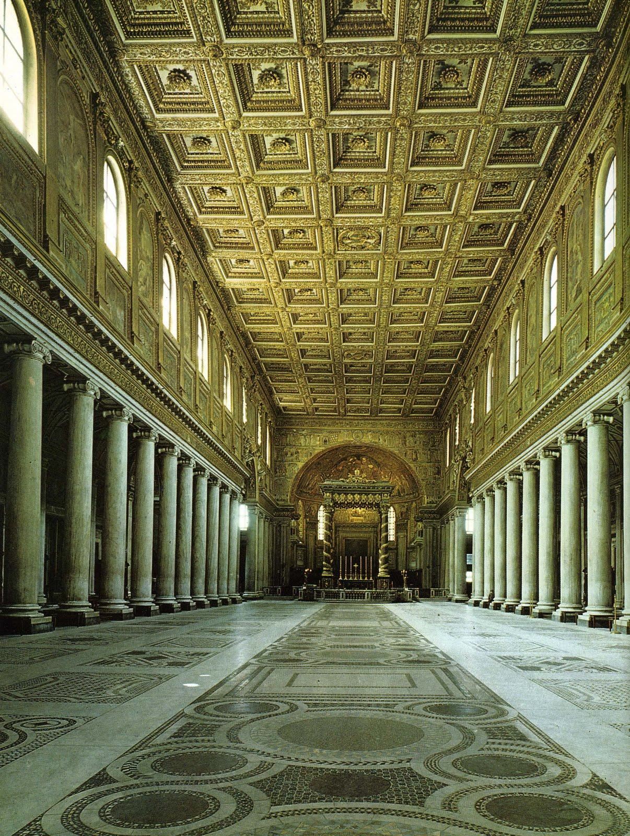

Santa Maria Maggiore, Rome. ca. 432-440
Mary is believed to be buried here
Ionic
Knave leading back to the Apse and into the

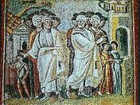
The Parting of Lot and Abraham
On the entablature and 42 of them are there
Symmetrical
House behind wall symbolizes city specifically Sodom
Canaan on the left

Illustrated Books
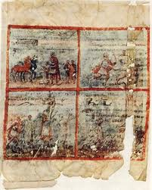
Scenes from the Book of Kings, Quedlinburg Itala, ca 425-450 ce. Tempera on vellum. 12” x 18” call it Quedlinburg Itala
Old Testament sccene. Saul meeting Samuel
Written words are instructions to the artist
“You make the Prophet speaking facing King Saul Sacrificing”
Artist was likely a Pagan b/c of pagan additions

SCULPTURE

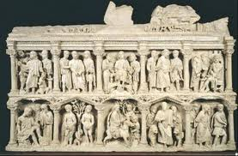
Sarcophagus of Junius Bassus. Ca. 359 ce. Marble. 3’10” X 8’
On his tomb it has Jesus and it said “Newly Baptized”
Idea of Christianity has changed since it says he wants to be remembered as a Christian. Christ Enthroned is in the center. Feet are rested on a god. Coelus is name of Diety (pagan god of heaven), Adam and Eve, the Passion to right of Jesus Enthroned. All registers inside Corinthian columns.
Very High Relief

BYZANTINE ART
Began with Justinian becoming emperor

Early Byzantine Art
Architecture

Ravenna, Italy has best preserved byzantine architecture. Ravenna was capital for section of Byzantine empire
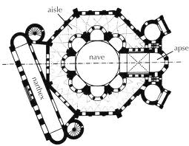
Church of San Vitale, Ravenna. 526-547 CE
Most important building in early byzantine. Octagonal plan, circular core with abitory (centrally planned) around it is a straight descendant of Santa Costanza
You have to physical turn to enter church to show area is holy
Raised gallery above main area mainly for women
Domed central planned churches dominated orthodoxChristians
Two very famous mosaics right next to altar

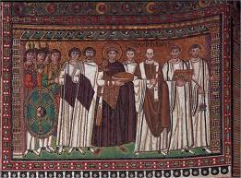
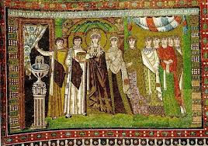
Emperor Justinian and his Attendants. Ca. 547 ce. Mosaic
Has halo around head. Holding Eucharist. 12 people around him. One man with a Bible and a cross with cross and p on it to connext him with Constantine. Depicts him going to his
The union of political and spiritual authority is shown in these mosaics.
Empress and Emperor are partaking in the mass since their picture is in the Church. Figures are tall, skinny and big eyes with almond shaped heads (typical). Looks forever static in church. Green ground shows natural but sky is gold.
Empress Theodora and her Attendants. Ca. 547 ce. Mosaic
Three wise men on the hem of her dress. Which is important because she is holding the blood. Green ground and gold sky.

Plan of Hagia Sophia, Istanbul. 532-537 ce.
Minarets attributed to Mosks which are giant towers around building
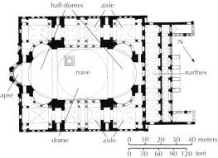
Buttresses are anything that supports a wall
Large medallions inside that have name of gods
Clerestory windows make Dome looks like floating
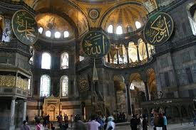
Circular dome on top of rectangular building you need a Pendentive – half arches that lead into a dome. Angels right under Dome. God was present in the building of this

SCULPTURE
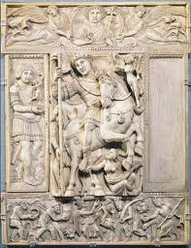

Justinian as Conqueror. Ca. 525-550 ce. Ivory., 13x10”.
Roman official holding wreath to show victory. Little fairy thing with wreath by horse’s head. Mother Earth was under horse to show he controls earth. relief showing his victories.
Jesus is doing the Shocker. Sun, Moon, and Star are depicted around Jesus. Shows he gives his blessing to Justinian.
Bottom register shows conquered people giving tribute to Justinian.

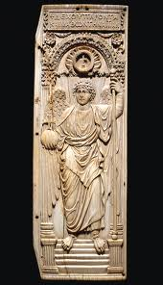
The Archangel Michael. Leaf of a Diptych. Early 6th century ce. Ivory. 17x5”
Probably part of leaf of Justinian. The top says “Receive these gifts and having learned their cause.” Basically im sorry for my sins Probably has a list of Justinian’s sins on the other side.
Image of Archangel is a descendant of victory.

ICONS – Eikon means image in Greeks.
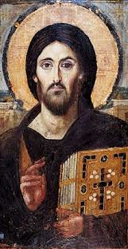
Christ. 6th century ce. Encaustic on panel, 34 x 17”
Byzantines believed this was really Jesus
Icons were generally Holy Figures
ON TEST FOR SURE
Show both Jesus is a condemner and forgiver. Left eye looks friendly but right eye looks like he is going to damn you.
Hand up depicts savior

